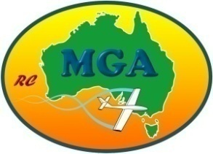
Mountain Gliding Australia
Membership Registration/Renewal Form

Full Name

Country

State

Age MAAA AUS No.

Current Wings through MGA or MAAA

Tick appropriate box

MGA
Bronze

MGA
Gold

MAAA
Gold

MAAA
Gold

MAAA
Gold

MAAA
Bronze

MAAA
Bronze

MAAA
Bronze
slope & thermal
slope & thermal
slope only
slope only
Powered Aircraft ........................................................
√
√

Glider .....
√
√
√
√

Helicopter ...................................................................
√
√
Tick appropriate box. (Left click a box then delete it.)

Current radio frequencies in use

If you would like to donate to the group, payment details are below.

Snail Mail Email & Direct Deposit
Post registration form and cheque to: Email registration form to:
MGA mountainglidingaustralia@dodo.com.au
P O Box Bass Vic 3991 Australia Direct deposit into Bendigo Bank to
Administrator – Ian Cole Mountain Gliding Australia
BSB 633-000 Account No. 46989652

